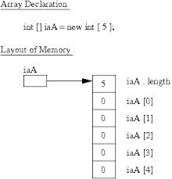
Array Lab #1

Choose a scenario that bests interests you……
Scenario 1
Create a runner program (has a main menu) that:
- Prompts the user for the number of current salespeople at the company
- Creates an array of the correct size based on the number of salespeople
- Create a “for loop” that will prompt and allow the user to enter the total sales for each salesperson. This step should enter the sales into an element of the array.
- After the loop that enters the sales, print out the total sales for the company and the average sales per salesperson.
- If you find this too pedestrian……also list the salesperson and amount that sold the most and the salesperson and amount who sold the least.
Scenario 2
Design an array that will hold a collection of objects that you find interesting. (Songs, movies, CD’s, coins, stamps) It could be anything that you collect or find interesting.
- Create the class for the item that will be entered into the array. You don’t need to write the whole class but think of:
  - Private instance variables and the constructor
- Write the runner file that creates the array of the correct type and size
- Using a “for loop”, populate the array with items from the class
- Using a loop, print out the contents of the array

Scenario 3
Explain how a programmer might get around the concept that arrays once declared and instantiated are rigid regarding size.
- Create a runner file that instantiates an array of a certain size
- Populate the array with data using a “for loop”
- Formulate a strategy on how you would allow the client to keep adding entries to the array even after it was filled with data.
- Code the strategy and then test to see if it is effective

