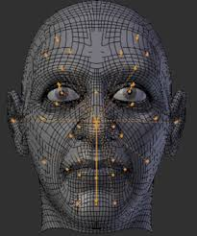
Final Chapter 3 Lab

Drawing a face using the Graphics Class in Java!!!!
- Open the Picture class from the M drive in the book classes folder, then save it to your Chapter 2 lab folder
- Study the code in the main method. A drawface() method has already been created for you
- See if you can figure out how to look at the API (Javadoc) for the Graphics class. Study the different methods
- Using the Graphics class, see how you can creatively construct a face using the various graphics methods
- Be sure and use the Color class as well to add interest
- Finally, see if you can add your name to the bottom right of the image using a method

