AP Computer Science
Rock, Paper, & Scissors Lab

Instructions: Do you know how to play “Rock, Paper, Scissors”? If not, look it up on line. You are going to create a program that simulates the game. You will play against the computer. The program needs to randomly assign the computer’s pick, and you need to use the Scanner to get the player’s pick. A series of “If” statements will need to be used to determine the winner. After each play, ask if the player wants to play again. When the player enters the sentinel value to exit, report the number of wins, losses, & ties.
Part A – The Design Phase (25%)
- Design you project using pseudo-code or flow chart format
- Make sure to include all aspects of your code
  - List any imports you need
  - List all variables and the related data type
  - Include all objects that need to be instantiated
  - Include user prompts
  - Describe random methods used
  - Detail the if or if-else logic
  - Include the output statements

Part B – The Code By Hand (25%)
- Write you code that is described in Part A
  - Include the “flowerbox”
  - Include all proper Java syntax
  - If you notice you are missing items, add them to the design document
  - Take special not of penmanship – print in pencil, dark, and large enough
Part C – The Dr. Java Code (25%)
- Enter your code in Dr. Java
- When finished, print out your code on the black and white printer
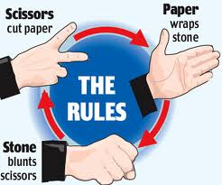
- Print out the interactions
Part D – The Error Log (25%)
- Log all errors encountered
- Include compile, run-time, and logical errors
- Detail why the error occurred
- Explain how you corrected the error

